LOGO Home About Us Service Industry System & Solution Projects Training Gallery Contact Us Enquiry
Note: Below every page mention the address and contact. And Back Button in each page.
Welcome to ORGATE AUTOMATION PVT LTD (Font colour as per picture in background in the Mid of the picture)
(Pictures of expertise in Automation Domain and its name)
HOME (initially black font colour but when PAGE is selected with grey background with white font colour in menu as mention above)

M/s Orgate Automation Pvt. Ltd. is led by a highly Automation field experienced team who bring a unique Industrial Automation Solutions of hands‐on more than 20 + Years industry experience and management expertise to the day‐to‐day operations of the company.
We believe in long term relationships with our clients by providing innovative industrial automation solutions, excellent customer service and greater value addition, thereby optimizing process functionality and improving production and operation efficiency of the Industry.
We provide many cost-effective solutions for Factory & Process Automation and executed many critical types Projects in different domains. We ensure that our customers receive the most cost effective and latest technology based solutions for their requirements & safe operations.

LOGO Home About Us Service Industry System & Solution Projects Training Gallery Contact Us Enquiry
ABOUT (initially black font colour but when PAGE is selected with grey background with white font colour in menu as mention above)
With Light grey colour Strip mention the open page branch.
ABOUT Home>About
<< Back
M/s Orgate Automation Pvt. Ltd established in 2017 with a core purpose of working in innovative Technology & Solution to the customer with improving Machine productivity, Process Plant operation stability, product quality, environment & Human safety.

M/s. Orgate Automation Pvt. Ltd is a leading Automation solutions & Services provider in different Automation Domains in Domestic & global locations i.e., Factory Automation & Process Automation with Siemens/ Rockwell / Honeywell / Mitsubishi / Delta / Schneider/Ge Fanuc/Omron Systems.

We provide engineering services to our customers by providing skilled Engineers for PLC / DCS / SCADA / HMI / AC-DC drives where we take up complete Project Engineering & Documentation, Software Development, and Installation & commissioning of projects.

In Turnkey automation solutions, we provide solutions with field instruments, Control/MCC panels, Control Systems, SCADA, and IoT solutions. We use best-in-class latest technology products for delivering these solutions.

We provide high quality integrated automation technology solutions and services in Industrial Automation using PLC/DCS and Drives for various application in industries like Automobile, Printing Machine, Paper, Steel, Special Purpose Machine, Material handling, Power Plant, Sugar Plant, Water Treatment Plant, Chemicals, Cement, Food & Breweries, Machine tools, Packaging, Pharmaceutical, Synthetic fibers and textiles, Oil and Gas, etc.

DIRECTORS/ LEADERSHIP TEAM:
- Mr. Raosaheb Pandule (with Picture)
- Mr. Sandip Shinde (with Picture)
Slogan: “Leadership is the ability to get extraordinary achievement from ordinary people”
VISION: To become a leading and preferred Automation and Solution Provider, through sustainable industrial and business development.
MISSION: To fulfil automation needs of the industry by providing cost-effective solutions and world class components which gives highest value for money.

LOGO Home About Us Service Industry System & Solution Projects Training Gallery Contact Us Enquiry
SERVICES (initially black font colour but when PAGE is selected with grey background with white font colour in menu as mention above)
With Light grey colour Strip mention the open page branch.
SERVICES Home>Services>Overview
<< Back
Software Development:
- Our team brings advanced technology & expertise across multiple PLC/DCS Control system platforms & Industrial domains. Our control team experts help, optimizing PLC/DCS programming standards and coding techniques to ensure reduced complexity, optimal performance, easy integration, and greater expandability. Our team works on Siemens, Rockwell, Honeywell, Mitsubishi, Delta, Schneider, Omron PLCs/ HMI platforms using programming languages Ladder, FBD, STL, SFC, ST, GRAPH.
- Communication Protocols: Profinet, Profibus, Ethernet TCP/IP, Ethernet/IP, CC-Link, DeviceNet, ControlNet, DH+, IO-Link, Modbus, OPC
- 3rd Party Integration: Vision, Bar code scanners, Printers, RFID & Other many devices
- IT Solutions: SQL, .NET, Visual Basics
- We help manufacturing companies embrace digital manufacturing Platforms by interfacing shop floor level PLCs and control systems to IIOT sensors, devices, and databases. We can bridge the gap between legacy PLC based manufacturing platforms and IOT by working with proprietary protocols, standards, and 3rd part devices
- Hardware & Software FAT support.

Installation & Commissioning:
- PLC, DCS Automation project site installation Supervision
- Panel Erection support
- Installation Field wiring & Termination.
- Cold loop Hot loop testing
- Calibration of loops
- Commissioning supports
- SAT & Project documentation Handover

Electrical Panel Manufacturing:
We have a manufacturing facility and a dedicated team for manufacturing of:
- PLC Control Panels
- MCC (Motor Control Centre) Panels
- PDB (Power Distribution Board)
- PCC (Power Control Panel)
- VFD panels
We provide end to end solution, implementation, and support which includes:
- Electrical Design & Development
- Control Panel Manufacturing
- Consulting
- Commissioning Support
- Implementation & Onsite Support
- Product Training
Electrical Designing:
- We have a dedicated team of design engineers for designing control panels, MCC (Motor Control Centre), PDB (Power Distribution Board), VFD panels, etc.
- Based on customer inputs, we design panel GA (General Arrangement) drawings, internal panel layouts, and detailed wiring drawings.
- Digitalization of old panels (Drawing preparation of old Panels from hardcopy/Control Panel)
- Upgradation of old Relay/Contactor logic to PLC.

Energy Management:
An ideal energy management solution for industries, manufacturing plants, commercial buildings, malls, or other applications where a high amount of energy is consumed by giving user control & management features. Generation of analytical graphs & reports.
- Avoid excess demand charges.
- Lessen the impact of utility power outages.
- Eliminate power factor penalties.
- Automatically control on-site generation.
- Faster data collection.
- Operating Equipment Efficiency.
- Usage-Based Cost Accounting.
- Load Profiling, Consumption Reporting.
- Demand Analysis, Shadow Billing.
- Power Quality.
- Electrical Distribution layout system.

Pictorial representation with analyzing charts and graphics.

Migration of Control system:
Our engineers are familiar with Siemens, Allen-Bradley, Honeywell, Mitsubishi, Delta, Schneider, Omron, and other manufacturers. On PLC/HMI/Drive Migration projects, we will work as per customer requirement to upgrade the original schematics, convert the existing Logic/Graphics to the new platform and fully test the control system once installed.
Why Migration Require:
- It gets harder and harder to find qualified service and maintenance staff.
- Partly, as a result, the maintenance budgets get higher every year.
- Because of the fact that the old system is no longer supported, there is a lot of work in maintenance and repairs.
- In some cases, the old system does no longer meets the production capacity and product quality that companies try to achieve.
- The Old System has low memory space which does not support the addition of I/O modules in the system.

Migrated systems:
- Migration S5 PLC Series to S7 PLC Series
- Migration S7-300 to S7-1500 PLC
- Migration PLC5 to ControlLogix and IO conversion
- Migration DH+ to Ethernet IP
- Migration DeviceNet to Ethernet IP
- Migration Profibus to Profinet
- Migration of RIO
- Migration of HMI & SCADA systems

Control Panel Retrofitting:
Upgrade from an existing level control to a new level control device. Evaluation of an existing system relative to various state and local codes.
- Evaluation of existing system and existing documents.
- Clear determination of the anticipated new retrofit configuration and subsequent control and operational parameters.
- Design control panel layout & wiring diagrams.
- Manufacture, delivery, install, and start-up of the new retrofit configuration.
- Provide O&M documentation, training, and warranty.
- On-site evaluation of existing problems
- Determine if the problem can be repaired onsite during the evaluation visit.
- Upgrade Relay/Contactor logic to New control system logic.

Repairs & Service Centre:
- Drives (AC-DC Drives)
- PLC Systems
- Human Machine Interface (HMI)
- Power Supply

LOGO Home About Us Service Industry System & Solution Projects Training Gallery Contact Us Enquiry
SERVICES (initially black font colour but when PAGE is selected with grey background with white font colour in menu as mention above)
With Light grey colour Strip mention the open page branch.
SERVICES Home>Services>Why Us
<< Back

- Why Us:
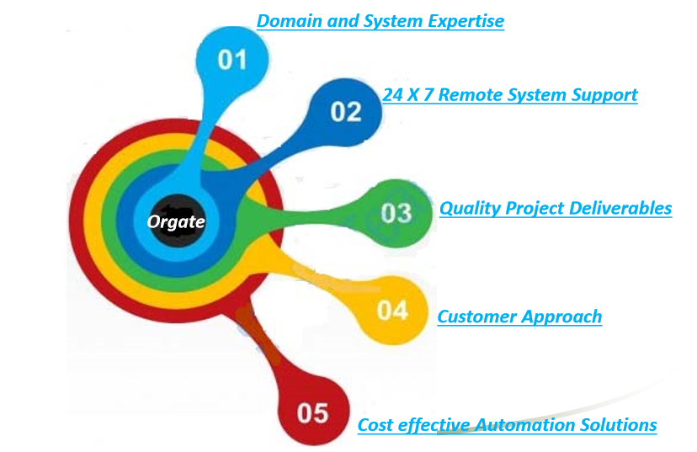

  - Industrial automation training facility on DCS, PLC, SCADA with simulators and process skid.
  - Our in-depth application knowledge helps us provide superior and cost-effective automation solutions to customers.
  - Due to our vast experience of vertical applications, we add the value to customers by recommending certain solutions which drastically improves the quality and productivity.
  - We share the latest trends and technologies of automation in these verticals to improve our customer's businesses & ROI.
  - 24×7 Remote System Support.

LOGO Home About Us Service Industry System & Solution Projects Training Gallery Contact Us Enquiry
SERVICES (initially black font colour but when PAGE is selected with grey background with white font colour in menu as mention above)
With Light grey colour Strip mention the open page branch.
Industry Home>Industry
<< Back
- Automobile:
- Key operations and subsystems integrated by MES System from Information Technology expertise include:
Production Control, Supervisory Control, Production Monitoring, Andon System, Process monitoring, Quality Systems, Material Management, Parts Call Systems, Part Pick Systems, Error Proofing Systems, Tracking Systems, Asset Management, Energy Management.
Our experts offer solutions in Automation for you are:
Press Room Body Shop
Assembly Line System
Material Handling
Paint Shop Automation
Furnaces & Foundries
Conveyor system
Body Shop Automation
Power Train Automation
Auto Component Manufacturing Lines/Machines.

- Chemical:
Orgate Automation Pvt. Ltd understanding of your control, information, and operational needs systems from our extensive hands-on experience in applications including:
- Ink Blending / Viscosity Control, Batch / Ingredient Metering, Sludge Press Automation, Surge Tank Level Control, Filling / Packaging Lines, Waste Water Treatment, Benchmarking, Gas Separator, Wet Soil Cap, Bulk Slurry, Ground Water Extraction, Tank Farm Automation, Reactor Pilot Plants, Weighing Systems, Continuous Blend, Solvent Recovery, Air Separation, Pickling Tank, Batching.
Pump Stations
- Pump start/stop sequence; pipeline pressure/flow control and pump/motor protection;
vibration protection and condition monitoring, and communications to the central SCADA system.
- Compressor start/stop sequence; turbine or motor speed control, pressure/flow control;
temperature, overpressure/over speed, and surge suppression, condition monitoring and communication with the control system.
Metering Stations
- Interface to temperature pressure and flow instruments, interface to electronic flow metering devices; as well as communications to SCADA systems.
- Water treatment plants
- Waste water treatment plants
- Water injection plants

- Paper & Printing:
Paper Industry, processed paper requires to be segregated into different kinds of thickness and diameter, this all done with the need for further customer need. So for this requires machinery provided with human interface.
- Paper Cutting.
- Paper Rolling.
- Conveyor system- Paper roll handling
- RFID systems- Product traceability

For the Printing Industry, we provide:
- Complete PPLC and Drive control.
- Registration control.
- Ink and water control.
- Third party interface with registration system(vision).
- Total automation for Greasing and oiling of Machine.
- Migration of older system to latest one with best optimised solutions.

- Cement Industry:
- Material handling
- Raw Meal
- kiln
- Ball Mill
- Packaging and Shipping

- Power Plant:
Orgate Automation Pvt Ltd offers you the complete range of automation applications in the simplest to the harshest environments, providing you with secure and reliable system solutions.
- Burner Management Systems & Boilers Control Systems
- Turbine Control System
- Coal/Ash handling System
- Water Treatment
- Plant Utility systems.
- Electrical Control & Monitoring

- Food and Beverage:
We offer solutions for the Food and Beverages Industry to reduce time-manufacture, contain costs and maintain quality, and provide seamless integration with your partners:
Our Expertise In
- Brewery Automation.
- Distillery Automation.
- Dairy Plant Automation.
- Vegetable Oil Plant Automation.
- Rice Mill Plant Automation.
- CIP Systems.

- Oil and Gas:
Petroleum industry to monitor, control, and protect equipment used in:
- Level control, Pump control and protection for pumps, Gas metering, Vapour recovery units, Boiler control and protection, Generation plant control and energy management, Process safety.

- Pharmaceutical:
Our Automation control systems along with HMI audit trail are designed in compliance with FDA - GMP regulations and User security according to authority level 21CFR11.10 (d) and ISA-S88 Standard Batch Process Design and Modelling.
We provide FDA validation service for 21 CFR part 11 documentation & system engineering as per GMP regulations. The following attributes are engineered and documented for implementation of the “21 CFR Part 11” compliant system.
- Audit Trail
- Electronic Record
- Access Security
- Archiving and Retrieval
- Validation Documentation (FDS, DQ, OQ, IQ)
1. FDS-Functional Design Specification.
2. DQ-Design Qualification.
3. IQ-Installation Qualification.
4. OQ-Operational Qualification.

- Metal Industry:
- Electric Arc Furnaces, Basic Oxygen Furnaces, Blast Furnaces, Reheat Furnaces, Lance Furnaces, Casting Controls, Continuous Casting, Hot and Cold Mills, Mill Automation Systems, Plate Mills, Slab Inventory, Soaking Pits, Combustion Control, and Dust handling system.
- Water Treatment Plants:
  - Screening and Straining.
  - Chemical Addition.
  - Coagulation and Flocculation.
  - Sedimentation and Clarification.
  - Filtration.
  - Water Distribution Systems.
- Waste Water Treatment Plants:
- Screening.
- Pumping.
- Aerating.
- Removing sludge.
- Removing scum.
- Killing bacteria.
- Wastewater Residuals.

Textiles:
With expertise in the textile industry, we offer a range of automation and control solutions specifically for fiber and textiles manufacturing and processing that can improve your operation.
- Yarn Production.
- Fabric Production.
- Finishing.
- Making up.
- Winder.

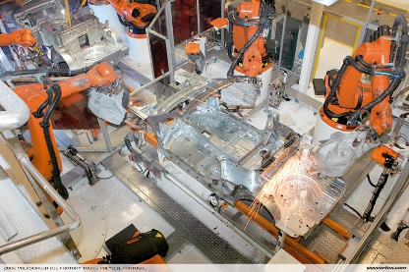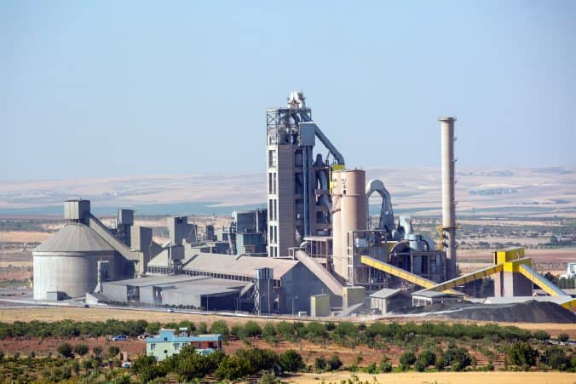
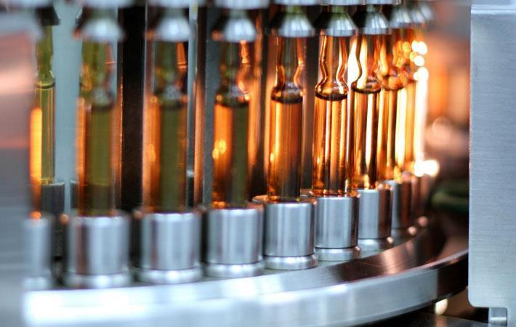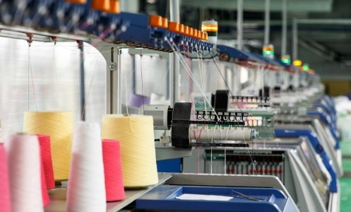
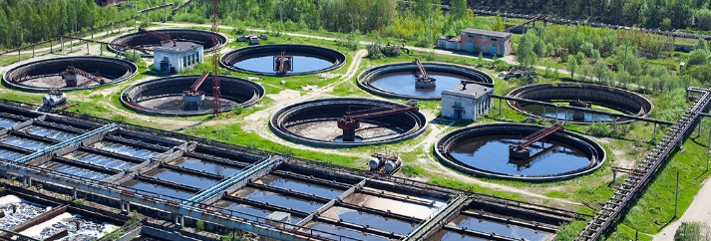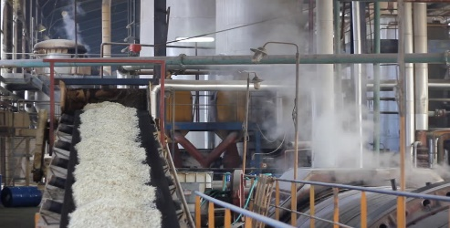
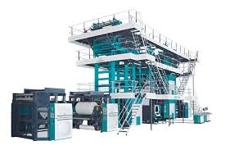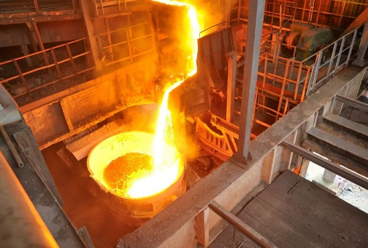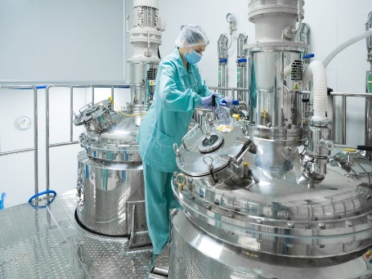
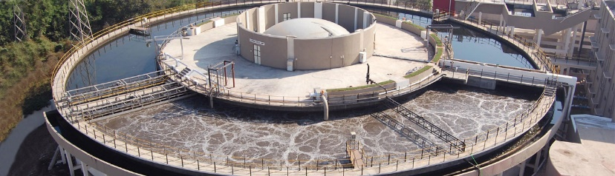

LOGO Home About Us Service Industry System & Solution Projects Training Gallery Contact Us Enquiry
SYSTEM & SOLUTION (initially black font colour but when PAGE is selected with grey background with white font colour in menu as mention above)
With Light grey colour Strip mention the open page branch.
SYSTEM & SOLUTION Home>System & Solution>RFID
<< Back
RFID belongs to a group of technologies referred to as Automatic Identification and Data Capture(AIDC). AIDC methods automatically identify objects, collect data about them, and enter those data directly into computer systems with little or no human intervention and stores the data in a database and analysed at a later time.
RFID Solutions:
  - Traceability: RFID tracks the product across the different segments of production and supply chain from source to destination to optimise the control.
  - Press Shop Tool Identification: An automatic identification system using RFID prevents errors for tool insertion and provide proper functioning.
  - Paint Shop Skid Identification: RFID system avoid production errors and provide reliable identification of skid in paint shop through the entire process.
  - Body Detection in Production: RFID system provide the current location of individual vehicles in entire production with the help of an RFID tag.
  - Inventory Management: To manage the products in the retail store as per regular and planned production by using an RFID tag.
  - Identification of Test Bottles: Detection of the test bottles and replace them with new bottles with continuous monitoring.
  - Detection of Goods Container: RFID is used to ensure the material flow and container’s current location in the process line.
  - Reverse Engineering Analysis: Reverse engineering and improper functioning in the system cycle can be easily identified with the RFID stored database and analysation.

Networking Scheme Picture of RFID:
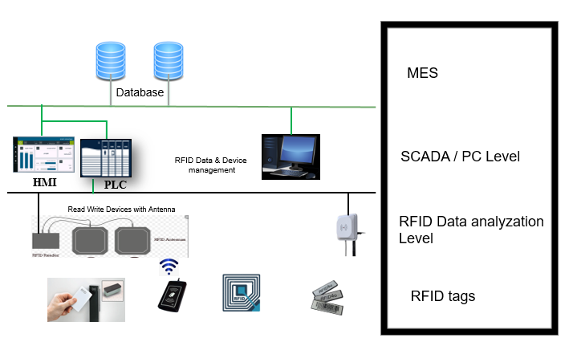

LOGO Home About Us Service Industry System & Solution Projects Training Gallery Contact Us Enquiry
SYSTEM & SOLUTION (initially black font colour but when PAGE is selected with grey background with white font colour in menu as mention above)
With Light grey colour Strip mention the open page branch.
SYSTEM & SOLUTION Home>System & Solution>Industry4.0
<< Back
Industry 4.0 heavily focuses on interconnectivity, automation, machine learning, and real-time data referred to as IIOT or smart manufacturing. Industry 4.0 is also facilitating new ways for humans and machines to work together, empowering businesses to achieve greater insights, reduce the risk of error, and make better decisions.
Smart manufacturing or connected enterprise enables the user to archive, analyze & optimize the cost factors associated with manufacturing processes. Major cost factors are:
- I- Raw Material Consumption
- Electric Power Consumption
- Manpower cost
- Utility Consumption
- Effective utilization of assets, like process units (machines, vessels)
- Industrial IoT enabled software solution implements production reports, Maintenance reports, Dashboard reports, OEE (Overall Equipment Effectiveness).
We deliver solutions in Digitization of Manufacturing, MES, MIS & IIOT, thus partnering in our customer’s journey towards fruitful implementation of INDUSTRY 4.0.
We Provide Following Solutions:
• Systems Development Life Cycle
• Deployment and Onsite Support
• Third Party System Integration Design
• Post Go-Live Support
• Product Training
- With deep understanding and delivery experience of Plant Floor Automation, we have expanded our capabilities of delivering IT solutions. We design and deploy Industry 4.0 solutions using technologies like ASP.NET, Visual Basic, and SQL DB.

MIS Report:
A management information system (MIS) is a computerized database that is organized and programmed in such a way that it produces regular reports on operations for every level of management in a company.
- Production Report
- Recipe Management
- Product Management
- Management Consolidated Reports
- Interface with 3rd Party Software
- Department wise Data collection and reporting
- Department wise production planning and reporting
- Safety Management System
- Interface with ERP, SAP, etc. Systems
- TPM (Total Productive Maintenance)
- Real-time Monitoring
- Operations/Detail Scheduling
- Dispatching Production Units
- Document Control
- Data Collection/Acquisition
- Labour Management
- Quality Management
- Process Management
- Maintenance Management
- Performance Analysis

Images for Industry 4.0:
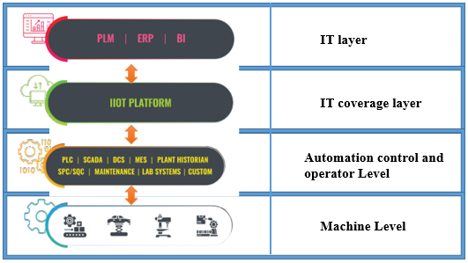
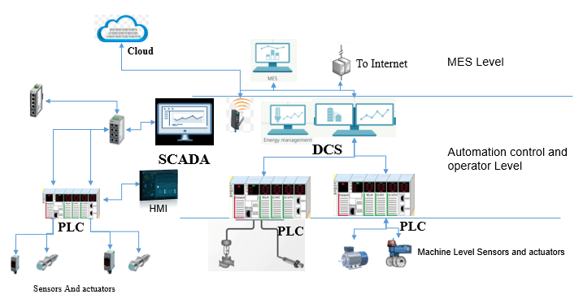
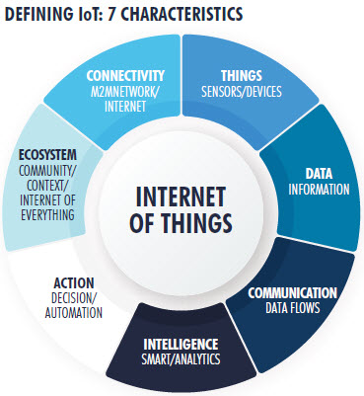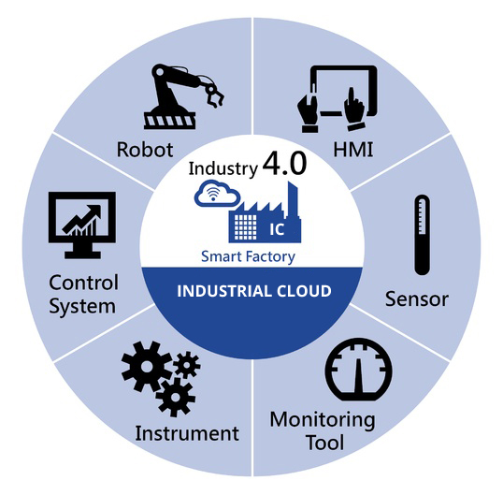

LOGO Home About Us Service Industry System & Solution Projects Training Gallery Contact Us Enquiry
SYSTEM & SOLUTION (initially black font colour but when PAGE is selected with grey background with white font colour in menu as mention above)
With Light grey colour Strip mention the open page branch.
SYSTEM & SOLUTION Home>System & Solution>PLC Migration
<< Back
Outdated PLCs continue to age, it becomes harder to find replacement parts and system maintenance becomes increasingly more expensive. Migrating to a modern PLC platform offers significant improvements to OEE (Overall Equipment Effectiveness), system reliability, parts availability, support, and efficiency.
When performing PLC integration or migration services, we do our best to reduce downtime and costs by maintaining your existing field wiring and enclosure footprint whenever possible.
Upgraded System:
Migrating S5 PLC Series to S7 PLC Series
Migrating S7-300 to S7-1500 PLC
Migrating PLC5 to ControlLogix and IO conversion
Migrating DH+ to Ethernet IP
Migrating DeviceNet to Ethernet IP
Migrating Profibus to Profinet

LOGO Home About Us Service Industry System & Solution Projects Training Gallery Contact Us Enquiry
SYSTEM & SOLUTION (initially black font colour but when PAGE is selected with grey background with white font colour in menu as mention above)
With Light grey colour Strip mention the open page branch.
SYSTEM & SOLUTION Home>System & Solution>Machine Safety
<< Back
Machinery Safety:
We design the safety functions up to PL e in accordance with EN ISO 13849-1 and SIL 3 in accordance with IEC 62061. We use Safety PLCs & Safety IOs. We have vast experience on Safety PLCs Siemens/Allen Bradly. Machine safety Integration

LOGO Home About Us Service Industry System & Solution Projects Training Gallery Contact Us Enquiry
PROJECTS (initially black font colour but when PAGE is selected with grey background with white font colour in menu as mention above)
With Light grey colour Strip mention the open page branch.
PROJECTS Home>Projects
<< Back
(Example): the data will be filled later as per main projects.
  - Metal Finishing Line:
PLC: 1756-L72S GuardLogix 5570 safety controller (1 No.)
HMI: Panel View Plus 7 (5 No.)
Drive: Powerflex 527
  - Body Part Manufacturing Line:
PLC: 1756-L72S GuardLogix 5570 safety controller (2 No.)
HMI: Panel View (6 No.)
Drive: Powerflex 525
  - Body Assembly Line:
PLC: CPU 1511F-1 PN; CPU 1511F-1 PN; CPU 1516-3 PN/DP (3 No.)
Drive: SEW (12 No.)

LOGO Home About Us Service Industry System & Solution Projects Training Gallery Contact Us Enquiry
TRAINING (initially black font colour but when PAGE is selected with grey background with white font colour in menu as mention above)
With Light grey colour Strip mention the open page branch.
TRAINING Home>Training
<< Back
To boost the value of an Individual for self & Organization Development. We Conduct training programs for Fresh Engineers / Working Professionals / End Users.
"VOICE" of Industry" is - Lack of trained Professionals / Fresh Engineers as per Industry requirement. Engineering Institutes results are touching Sky. We try to fill the GAP between Industrial requirement and the Technical skill of the candidate by “Re-Engineering”.
Training and Development help in Optimizing the utilization of the human resource, increasing the job knowledge and skills of employees at each level, that further helps to expand the horizons of the human intellect, overall personality development of the employees. So the employees are able to achieve the Organization goals as well as their individual goals.
We undertake training services for customised training based on installation platforms and specific demands of contents and schedules. These hands-on training help the customer for routine maintenance and reduction in downtime.

Training Program:
PLC:
• Identification of control inputs & outputs
• Hardware control & control through PLC
• PLC Architecture
• Selection of PLC
• Interfacing control I/O’s to PLC
• Basic Ladder Logic Instructions, Contact, coils & PLC scan.
• Control using various control instructions like timer, counter, math etc.
• Analog control and Data handling
• Downloading & Uploading of PLC programme
• Communication Protocol and configuration.
• Troubleshooting
• Practical Exercises

HMI:
• Need, Operation & Fundamentals of HMI
• Types of HMI
• HMI specification & selection criteria
• HMI configuration & application
• Various setting from HMI
• Interfacing with PLC
• Project development-Screens & configuration
• Defining tags
• Recipe, Alarms, Security
• Communication Protocols
• Transferring project to HMI
• Troubleshooting
• Practical Exercises

Drives:
• Principle of 1Ø & 3Ø Motors
• DOL & Star/Delta starter
• Power devices – Thyristors & IGBTs
• Single & Four Quadrant Application
• Speed Control & Torque-Tension mode
• Winding – Unwinding application
• Complicated application – Close loop with PID
• Diameter calculation for winder-unwinder
• Communication with PLC
• Troubleshooting
• Practical Exercises and Demonstration
• DC DRIVES (Analog and Digital)

Instrumentation and Control:
• Basics
• Introduction to Industrial processes
• Need of Process control
• Process Control Techniques
• Sensors –Temperature, Pressure, Reed, Level, Flow
• Actuators – switches, Pressure switches, Transducers, Transmitters, I/P Converters
• Control loops-Open & Closed loop
• Control loops linking with PLC
• Manual & Auto tuning of PID controller using Relay, SSR o/p, mA o/p of PID controller
• Troubleshooting
• Practical Exercises
• Demonstration

SCADA:
• Introduction to SCADA
• Need, Concept & Basic features of SCADA
• Configuration of different drivers
• Database of Tags & it’s use
• Graphic Screens – Concept & need
• Interfacing with PLC and Interfacing simulation of PLC application
• Digital & Analog supervision through Graphic Screen
• Digital & Analog control through Graphic Screen
• DATA Acquisition and Report generation through SCADA
• Messages & Alarms
• Troubleshooting
• Practical Exercises

Electrical Automation:
• AC & DC power supply
• CT, PT & Isolation transformers
• AC & DC load connections in electrical
• Measuring devices-Multimeter, Tester
• Load calculation - series & parallel loads Front panel logics
• Devices on panel for user interface
• Control using switching contacts – NO/ NC and its Configuration.
• Positive & negative switching & ascertaining o/p voltage Relay & Contactor logic
• AC/DC Relays - Load control application
• Contactors for load control – Power & auxiliary Switchgear & Control
• Switchgear-operation, Control & Selection
• MCB, MCCB, ELCB, MPCB, SFU, OLR AC Motor & Starters (DOL and Star/Delta)
• Selection of components as per rating of Motor & Heater application

Training Duration:
Sr. No. | Course Detail | Duration | Total Duration
1. | Electrical Module | 6 | 3 Months
2. | Electronic Module | 6
3. | Instrumentation and Control | 6
4. | AC-DC Motor and Drives | 6
5. | Relay Logic / Contactor Logic | 30
6. | PLC (Siemens/Rockwell/Mitsubishi/Delta/Omron)
7. | I/O control and Troubleshooting
8. | HMI (Siemens/Rockwell/Mitsubishi/Delta) | 10
9. | SCADA | 10
10. | Communication Protocols (Profinet/Profibus/MPI/PPI/Ethernet IP/DeviceNet/ControlNet) | 10
11. | Simulation/Emulator
12. | Live Industrial Projects | 5
13. | Personality Development | 3

Sr. No. | Course Detail | Duration | Total Duration
1. | Relay Logic / Contactor Logic | 20 | 1.5 Month
2. | PLC (Siemens/Rockwell/Mitsubishi)
3. | SCADA | 7
4. | HMI (Siemens/Rockwell) | 7
5. | Communication Protocol (Profinet/Profibus/Ethernet IP/MPI) | 6
6. | Live Industrial Projects | 5

Sr. No. | Course Detail | Duration
1. | Relay Logic / Contactor Logic | 15 Days
2. | PLC (Siemens/Rockwell)
3. | HMI (Siemens/Rockwell)
4. | Communication Protocol (Profinet/Profibus/Ethernet IP/MPI)

LOGO Home About Us Service Industry System & Solution Projects Training Gallery Contact Us Enquiry
CONTACT US (initially black font colour but when PAGE is selected with grey background with white font colour in menu as mention above)
With Light grey colour Strip mention the open page branch.
GALLERY Home>Gallery
<< Back

LOGO Home About Us Service Industry System & Solution Projects Training Gallery Contact Us Enquiry
CONTACT US (initially black font colour but when PAGE is selected with grey background with white font colour in menu as mention above)
With Light grey colour Strip mention the open page branch.
CONTACT US Home>Contact Us
<< Back

CONTACT US:
Visit Us: (address with Google map)
Office ‐2‐02, Yogi Villa, Plot No‐283, Sect ‐04, Pradhikaran Moshi, Pune Nasik Highway Moshi Pune 412105
Email Id.: sandip.shinde@orgateautomation.com
raosaheb.pandule@orgateautomation.com
Contact: +919503939364
+919503936361

For Queries fill the following detail.
Name: Address:
Company: City:
Email Id: Pin:
Phone/Telephone: State:
Fax No.: County:
Comment Box:

LOGO Home About Us Service Industry System & Solution Projects Training Gallery Contact Us Enquiry
ENQUIRY (initially black font colour but when PAGE is selected with grey background with white font colour in menu as mention above)
With Light grey colour Strip mention the open page branch.
ENQUIRY Home>Enquiry
<< Back
Enquiry Form

Name of Company:
Contact Person:
Address / City / Location:
Email Id:
Phone No.:
Requirement Details:
Attach File: (Document file attach)
Verify Code: (Code and Code box)

CAREER:
Slogan: “The journey of a thousand miles begins with a single step.”
We strongly believe that life at Orgate Automation Pvt. Ltd leaves you a better individual than when you first walked through the doors of Orgate Automation Pvt. Ltd. Our culture is all about offering everyone working here with the opportunity to develop technical knowledge, creativity and integrity while growing themselves, their careers, and our business.

Connect with Us:

Name of Candidate:
Email Id:
Phone No.:
Present Status:
Area of Expertise:
Message:
Resume:(Document file)

Submit Reset

Slogans:
- “The man who has confidence in himself gains the confidence of others.”
- “What you lack in talent can be made up with desire, hustle and giving 110% all the time.”
- “I think goals should never be easy, they should force you to work, even if they are uncomfortable at the time.”
- “You don’t have to be great to start, but you have to start to be great.”
- “The way get started is to quit talking and begin doing.”
- “The pessimist sees difficulty in every opportunity. The optimist sees opportunity in every difficulty.”

